Contents

Contents - 1 -
1 Porting the RIL code - 2 -
2 Building the RIL code - 3 -
3 Using the RIL library - 3 -
4 Debugging the RIL library - 6 -
5 Adding a new request to RIL - 7 -

SCOPE

This document is a brief description on:
- How to port the RIL code to one’s Android system.
- How to build the RIL code on one’s Android system.
- How to use the RIL library on one’s Android system.
- How to debug the RIL library on one’s Android system.
- How to add a new request to RIL on one’s Android system.

1 Porting the RIL code
If the source code has been received from SIMCOM one can start to port the code to his own Android system.
Since the source code from SIMCOM is based on Android 2.3, so please make more patiently and carefully while porting the code to the system other than 2.3.
All the modification to the source code by SIMCOM is covered under SIMCOM_RADIO feature, so one only needs to port these codes.

Following files need to be ported:

Ril_commands.h
Ril.h
Ril.cpp
Reference-ril.c
Radiooptions.c
Reference-ril-simcom.c //add by simcom
Reference-ril-simcom.h //add by simcom

As the reference code may be different from SIMCOM, one may need to modify some other files

1. system/core/init/property_service.c:
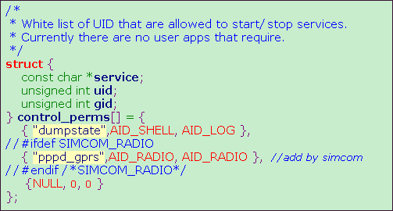
If this file has been modified, one needs to rebuild and replace the “init” process.

2. external/ppp/pppd/ipcp.c:
static void ipcp_up(f)
{
……
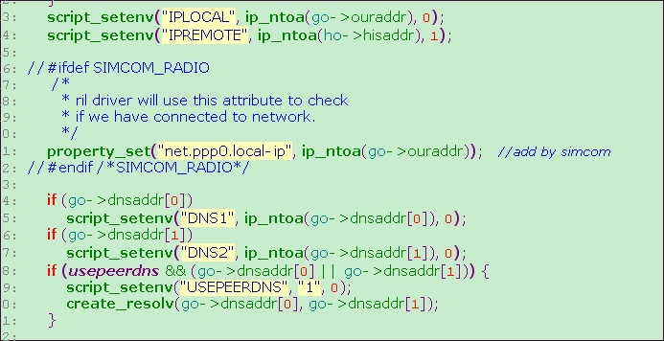
……
}
If this file has been modified, one needs to rebuild and replace the tool “pppd”.

2 Building the RIL code
After porting the source code, one needs to re-compile the RIL code in order to generate the new RIL library. There is no need to re-compile the whole Android system, RIL Library is enough.
Following steps depict how to compile the RIL code based on my environment:

1. cd ~/work/froyo_r2
2. . build/envsetup.sh
3. choosecombo 1 1 imx51_bbg 3
4. mmm ~/work/froyo_r2/hardware/ril/reference-ril // libreference-ril.so generated
5. mmm ~/work/froyo_r2/hardware/ril/libril // libril.so generated

If all right the library: libreference-ril.so, libril.so will be created.

3 Using the RIL library
Now two Library files: libril.so and libreference-ril.so are existed, together with another three script files (init.rc, init.gprs-pppd, 3gdata_call.conf which can also be received from SIMCOM) one can use his device to dial, send/receive sms, browse internet and so on.
Following paragraph will use data call as an example on how to use RIL library:

3.1 Prepare
- Refer to SIMCOM’s init.rc please modify the init.rc on one’s own device.
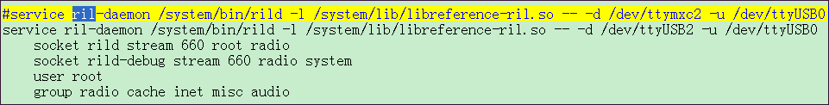
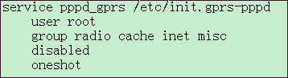
- Put the file: init.gprs-pppd,3gdata_call.conf to the directory: /etc/
- Make sure the tool “chat” is existed on the device since SIMCOM’s pppd will use this tool to dial-up.
- Make other tools ready like pppd and dial tools; of course most of them are implemented by Android system.

3.2 Use
Now one can setup a data call:
- Create an APN
Before dial-up one must create an APN first.

Android Menu “Settings -> Wireless & networks -> Mobile networks -> Access Point Names -> New APN”
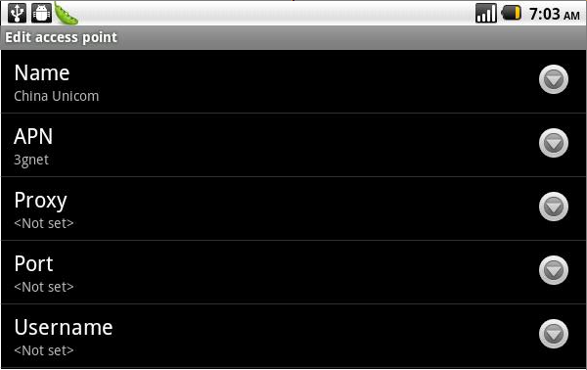

The APN must be set rightly, or the device can’t connect to network successfully.

- Select the right APN
After APN has been created, one needs to let such APN become effective:
Android Menu “Settings -> Wireless & networks -> Mobile networks -> Access Point Names”
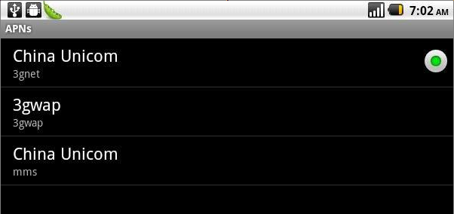

3． Connect to the network.
Now APN is OK, the device is ready to dial-up.

Android Menu “Settings -> Wireless & networks -> Mobile networks -> Data enabled”
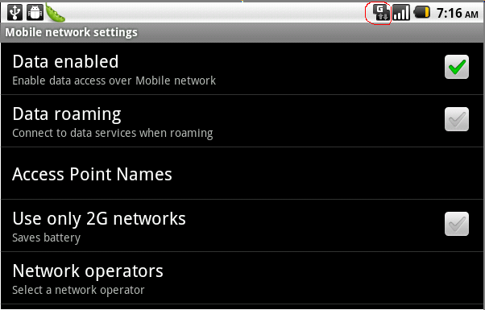

If all right now one can browse the website.
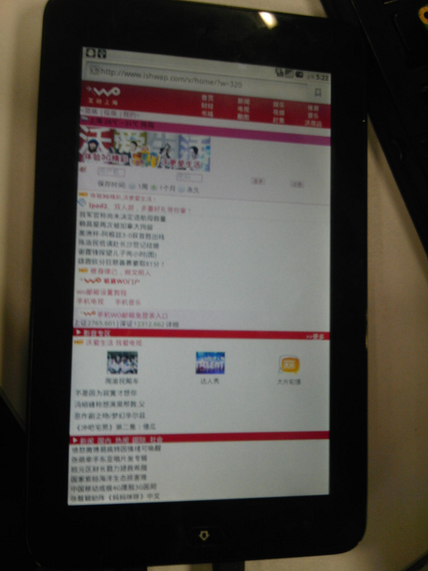

4 Debugging the RIL library
During the R&D process any problems may be encountered, one can use the macro “LOGD/LOGE/LOGW” in code to print log information, and use adb on the PC side to show these logs, also one can save these logs and send to SIMCOM, SIMCOM will help to analyze the bugs.
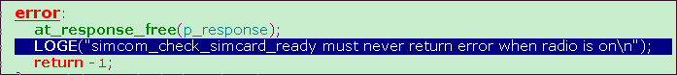

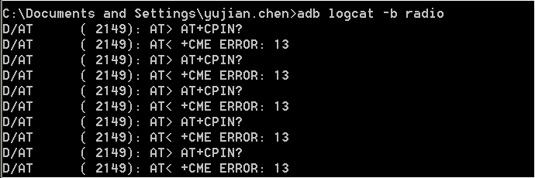

5 Adding a new request to RIL
Since SIMCOM has not implemented all of the functions in RIL, so one may need to add the new request to RIL by himself.
Following steps will use “Enable/disable GPS” as an example on how to add a new request to RIL code.
- define the new request in ril.h
hardware\ril\include\telephony\ril.h:
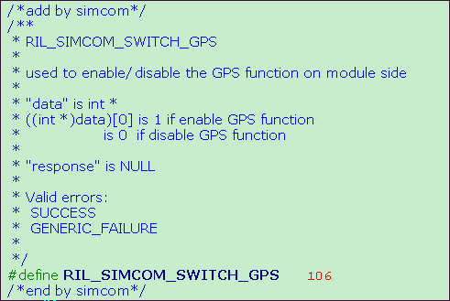
- deal with the request
hardware\ril\reference-ril\reference-ril.c:
static void OnRequest(int request, void *data, size_t datalen, RIL_Token t)
{
…
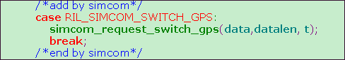
…
}
The GPS application will send a request to RIL in order to operate GPS; of course in this case it must send the request “RIL_SIMCOM_SWITCH_GPS”with the appropriate parameter to RIL. Or one can change this request to adapt the GPS application.
- implement the request:
Hardware\ril\reference-ril\reference-ril-simcom.c:
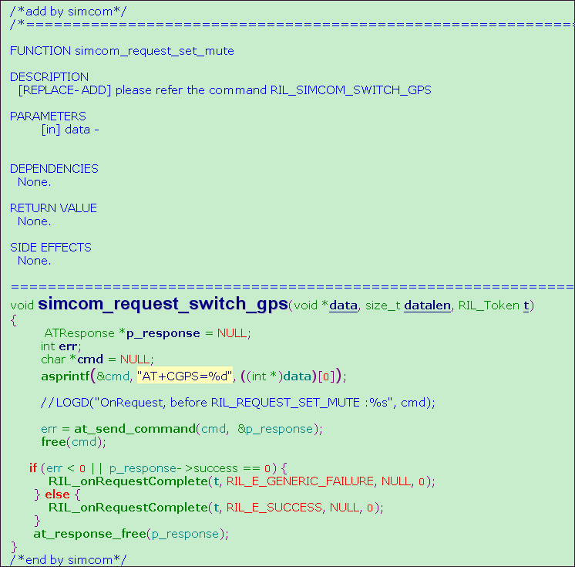
Now the GPS function on module side is enabled, and one can get GPS data (NMEA format) from ttyUSB1 (this is the NMEA port of SIMCOM module).
- Get location information
Now the GPS data is outputted over the ttyUSB1 by SIMCOM module, and the GPS application needs to get the data and parse it in order to get the valid location information.

